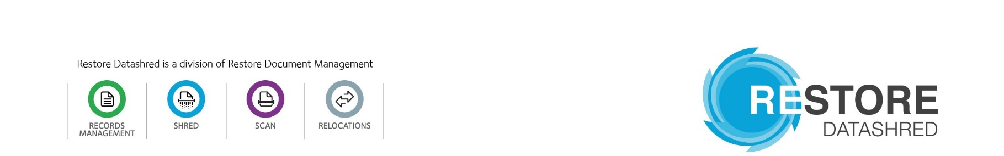

Job Title | Operations Administrator
Department. | Operations
Location | South Kirkby
Reports to (direct) | Depot Manager

MAIN PURPOSE OF JOB

Reporting into the Depot Manager you will carry out all administration duties as necessary. With an emphasis on first class customer service and assisting in supporting the Secure Collection Operatives/Assistance to complete their daily workload. You will ensure that all enquiries are dealt with quickly and accurately and we are communicating with all customers to meet their expectations, and all daily and weekly tasks are completed within the relevant time scales. The role will require a significant amount of problem solving, planning and resolution in a very fast paced dynamic team environment.

KEY TASKS

- Assist the administration and management teams with all aspects of planning daily work, booking jobs, permits, securing parking facilities and managing drivers’ times.

- Realtime dynamic routing of vehicles to ensure 100% completion of jobs per day.

- Booking jobs, reporting failed jobs, rearranging jobs and communicating dates and times with the customer (internal/external).

- Regular communication with the SCO’s and SCA’s throughout the day to support them.

- Daily debriefing of the SCO’s / SCA’s.

- Evaluating routes and revenue to make sure we are using the correct vehicles for the correct jobs and being as efficient as possible.

- Deal effectively with internal and external customers and liaise with other staff members to ensure that customer requirements are met efficiently.

- Fixed routing and Input incoming orders and contracts into the relevant computer system.

- Liaise with the depot management regarding route planning and add additional visit requests by customers to existing routes to maximise route efficiency.

- Report any discrepancies on route paperwork swiftly and make account amendments as required.

- To complete company paperwork accurately and promptly in line with company procedures.

- Processing of key system and route clear downs.

- Allocate workloads to drivers as appropriate.

- Assist with Management Administration

*** The above is not an exhaustive list but an outline of your duties. All Restore Datashred employees need to be aware that they may be asked to perform tasks and be given responsibilities as reasonably requested.

SKILLS, QUALIFICATIONS, EXPERIENCE:

- Good communication skills, both written and verbal.
- Excellent telephone manner.
- Ability to apply the principles of customer care.
- Highly competent in standard software packages and willing to learn new ones.
- Ability to prioritise own workload.
- Must have the ability to maintain confidentiality and discretion at all times.
- Previous experience in a fast-paced customer focused environment.
- Ability to work under pressure showing flexibility when required.
- Microsoft knowledge, in particular Excel.
- Being able to work as part of a close team.

COMPETENCIES

- Good at communicating and interacting with the driving team.
- Commitment to delivering excellent customer service.
- Able to work using own initiative.
- Problem solving.
- Achieves/exceeds KPI targets.
- Takes ownership of tasks
- Deals, assertively and politely with internal and external customers

HEALTH & SAFETY RESPONSIBILITIES

• Adhere to all Company Policies and Procedures contained in the Information Security, Environmental, Health and Safety and Quality Management Systems
• Report any Information Security, Environmental, Health and Safety and Quality incidents to your supervisor

Managers are responsible for training staff on Company Policies and Procedures contained in the Information Security, Environmental, Health and Safety and Quality Management Systems

APPROVALS:  Line Manager  Name: ………………………………………………...  Signature:……………………………………  Date:………………………………………… | Post Holder  Name: ……………………………..………………………..  Signature:…………………………………………  Date:………………………………………………

