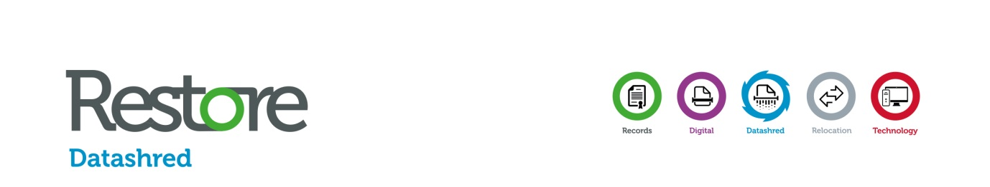

Job Title | Operations Administrator
Department. | Operations
Location | Coventry
Reports to (direct) | Operations Manager

MAIN PURPOSE OF JOB

Reporting into the Operations Manager you will carry out all branch administration as necessary. With an emphasis on first class customer service, you will ensure that all enquiries are dealt with quickly and accurately, and all daily and weekly tasks are completed within the relevant time scales. The role will require a significant amount of problem solving, planning and resolution.

KEY TASKS

- Deal effectively with internal and external customers and liaise with other staff members to ensure that customer requirements are met efficiently.

- Liaise with the Operations Manager regarding route planning and add additional visit requests by customers to new / existing routes to maximise route efficiency.

- Report any discrepancies on route paperwork swiftly and make account amendments as required.

- To complete company paperwork accurately and promptly in line with company procedures.

- Assist the Operations Manager with vehicle management.

- Processing of key system and route clear downs.

- Process and monitor parking fines ensuring accurate records are kept.

- Allocate workloads to drivers as appropriate.

- Assist the Operations Manager with the driver debriefing at the end of each.

- Ensure timely and proactive communication with service drivers throughout the working day.

*** The above is not an exhaustive list but an outline of your duties. All Restore Datashred employees need to be aware that they may be asked to perform tasks and be given responsibilities as reasonably requested.

SKILLS, QUALIFICATIONS, EXPERIENCE:

- Good communication skills, both written and verbal.
- Excellent telephone manner.
- Ability to apply the principles of customer care.
- Highly competent in standard software packages and willing to learn new ones.
- Ability to prioritise own workload.
- Must have the ability to maintain confidentiality and discretion at all times.
- Previous experience in a fast-paced customer focused environment.
- Ability to work under pressure showing flexibility when required.

COMPETENCIES

- Commitment to delivering excellent customer service.
- Able to work using own initiative.
- Problem solving.
- Achieves/exceeds KPI targets.
- Takes ownership of tasks.
- Deals empathetically, assertively and politely with internal and external customers

HEALTH & SAFETY RESPONSIBILITIES

• Adhere to all Company Policies and Procedures contained in the Information Security, Environmental, Health and Safety and Quality Management Systems
• Report any Information Security, Environmental, Health and Safety and Quality incidents to your supervisor

Managers are responsible for training staff on Company Policies and Procedures contained in the Information Security, Environmental, Health and Safety and Quality Management Systems

APPROVALS:  Line Manager  Name: ………………………………………………...  Signature:……………………………………  Date:…………………………………………… | Post Holder  Name: ……………………………..………………………..  Signature:…………………………………………  Date:………………………………………………

